 

|  |
| --- |
| **FPT- aptech computer education** |
| eProject Report |
| Team 6  Photoprinting |
|  |
| |  |  | | --- | --- | | **FAI T1608E – Group6** | | | **Group Member** | Trần Khánh Dương (L)  Nguyễn Anh Tuấn  Nguyễn Mạnh Hùng  Lê Duy Khuyến  Lương Khánh Duy | | **Instructor** | Nguyễn Tuân | |
|  |

|  |
| --- |
| - Hanoi, 10/2018 - |

Contents

1. Introduction 3

2. Problem Definition 3

2.1. The Current System 3

2.2. The Proposed System 4

2.3. Development Environment 5

3. Requirements and Business Flows 6

3.1. Customer Requirements 6

3.2. Activity Diagram 7

3.3. Use Case Diagram 7

3.4. Use Case Specification (optional) 7

3.5. Other Concerns<Optional> 8

4. Design 9

4.1. System Architecture 9

4.2. Class Diagram 9

4.3. Class Diagram Explanation 9

4.4. Sequence Diagram (Optional) 9

4.5. Collaboration Diagram (Optional) 9

4.6. State Diagram (Optional) 9

4.7. Entity Relationship Diagram 9

4.8. Database Design 9

4.9. Algorithms (optional) 10

4.10. Others (optional) 10

5. System Prototype 11

6. Management and Project Planning 12

6.1. Management Approach 12

6.2. Project Plan 12

6.3. Task Sheet 12

6.4. Meeting Minutes (Optional) 12

7. Checklists 13

7.1. Check List of Validation 13

7.2. Submission Checklist 13

8. Screenshots 13

9. Coding Convention 13

10. User Guide 14

11. Other Concerns<Optional> 15

Appendix 16

Glossary [Optional] 16

References [Optional] 16

Others<Optional> 16

# Problem Definition

## Problem Abstraction

“MyImage” is a group of people who wants to develop an online site

were the user can upload his or her photographs and can order them

for printing. A customer can have a set of digital photographs in his

desktop which he/she wants to print. He/she can provide the

application the path to the folder where the photographs are stored

and can choose the photos that he/she wants to print and choose the

size of the prints. The application will calculate the price after

downloading the price information from the database for the different

print sizes and show it to the user. The user will enter his/her credit

card/other payment option (or choose any other mode of payment)

and shipping information if he/she wants to go ahead with the order. If

the credit card information is found correct, the photos are uploaded to

the server and a purchase order is created in the database.

enter the mode of payment (credit card/direct payment in the

nearest branch office) and the shipping address. If credit card

option is chosen, the credit card information will be encrypted

and sent to the server for verification.

## The Proposed System

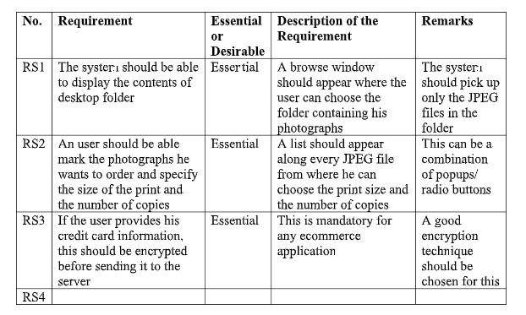

## Development Environment

Our client wants the application to perform the following tasks :

* Customers can:

1. Visit website
2. Register or login to website.
3. Order images.
4. New order information
5. Images size option.
6. Verify order and payment.
7. Update profile.
8. View history order.

* Admin can manage:

1. Manage user account.
2. Manage order.
3. Manage history order.

# Requirements and Business Flows

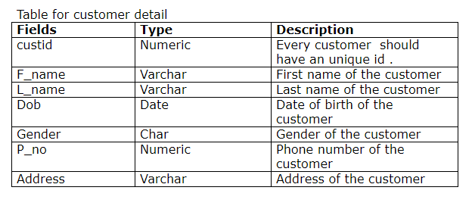

## Customer Requirements

Customer Requirement Specification

Our client, MyImage wants the following actions to be implemented.

1. The users have to register himself with the site before using the

functionality. After registrations user id and password will be

provided to the user. Through which he can login.

2. The price information for the different print sizes will be stored in

the database.

3. The user will upload JPEG files from his desktop, which he wants

to print.

4. The application will show all the jpeg files in the folder to the

user. The user can then choose the size(s) and the number of

prints that he/she wants to print for each size for each

photograph.

5. The application will calculate the total price for the order.

6. If the user decides to buy the prints, he/she will be asked to

enter the mode of payment (credit card/direct payment in the

nearest branch office) and the shipping address. If credit card

option is chosen, the credit card information will be encrypted

and sent to the server for verification.

7. The server will decrypt the credit card information and verify it.

If found correct, payment will be completed.

8. A purchase request will be created in the database. The

purchase order number will be provided to the user

9. An administrator user then can see the purchase request and

can execute the same.

10. Once the photos are printed and shipped, the directory

containing these photographs will be deleted from the server.

11. The admin will decide the price and other things. Proper

validation should be applied.

## Activity Diagram

1. Activity diagram “Project”

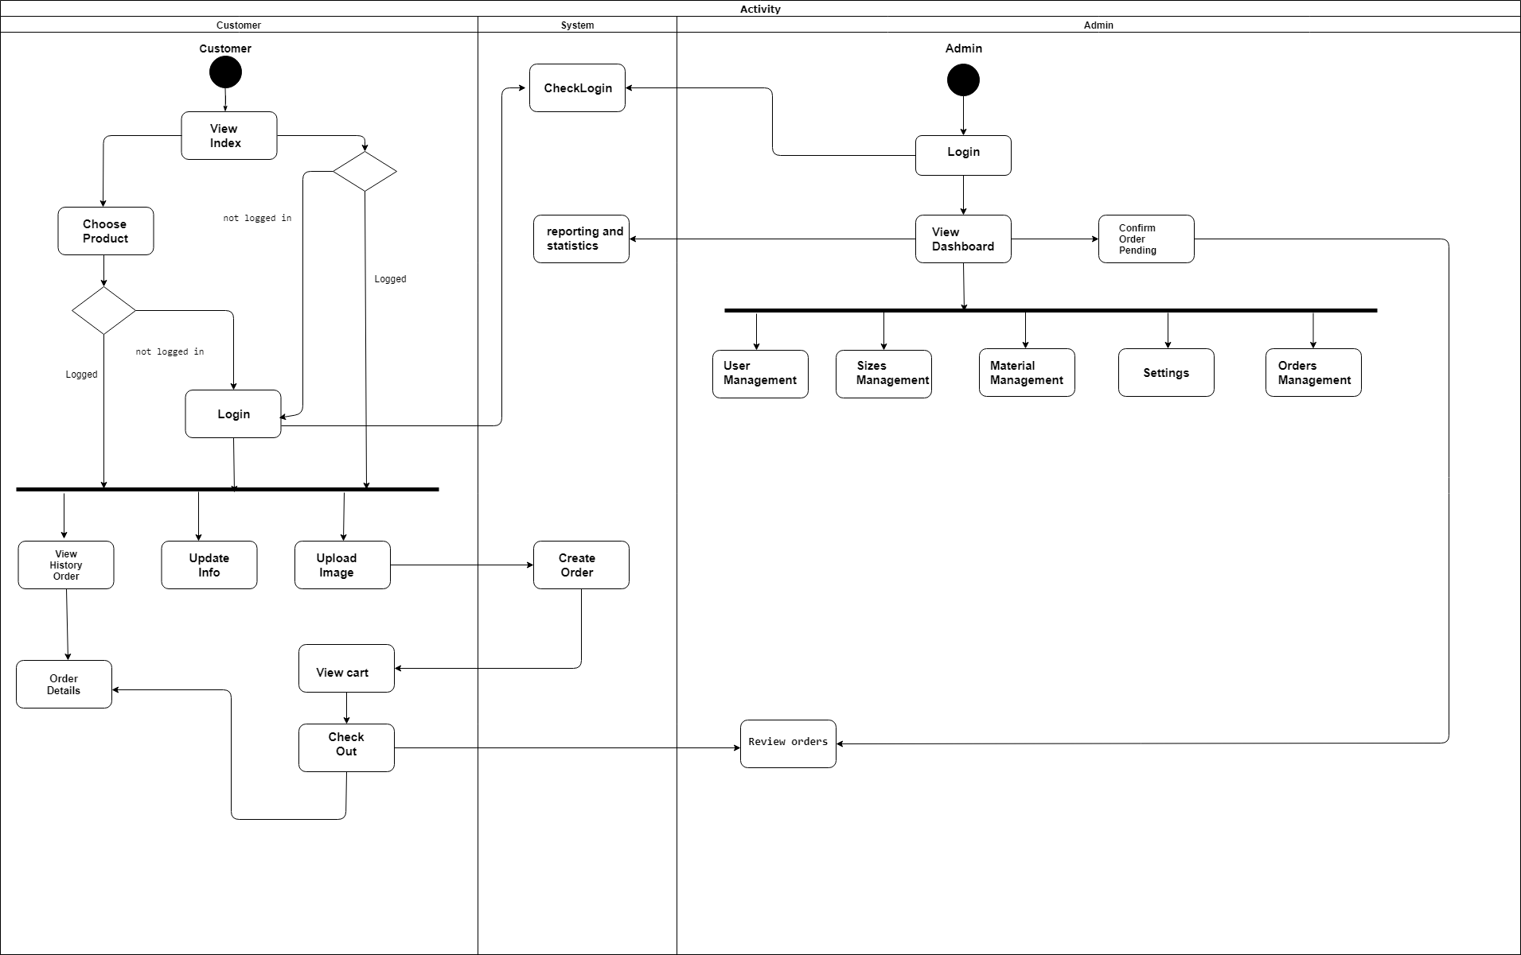

1. Activity diagram “ Register”

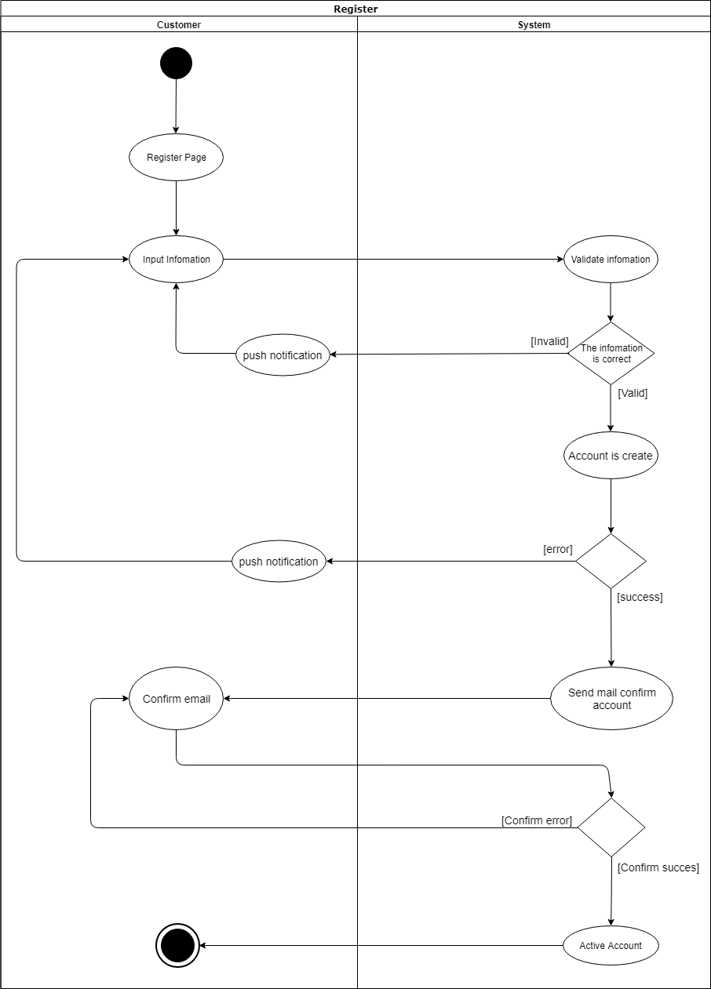

1. Activity diagram “UpdateInfo”

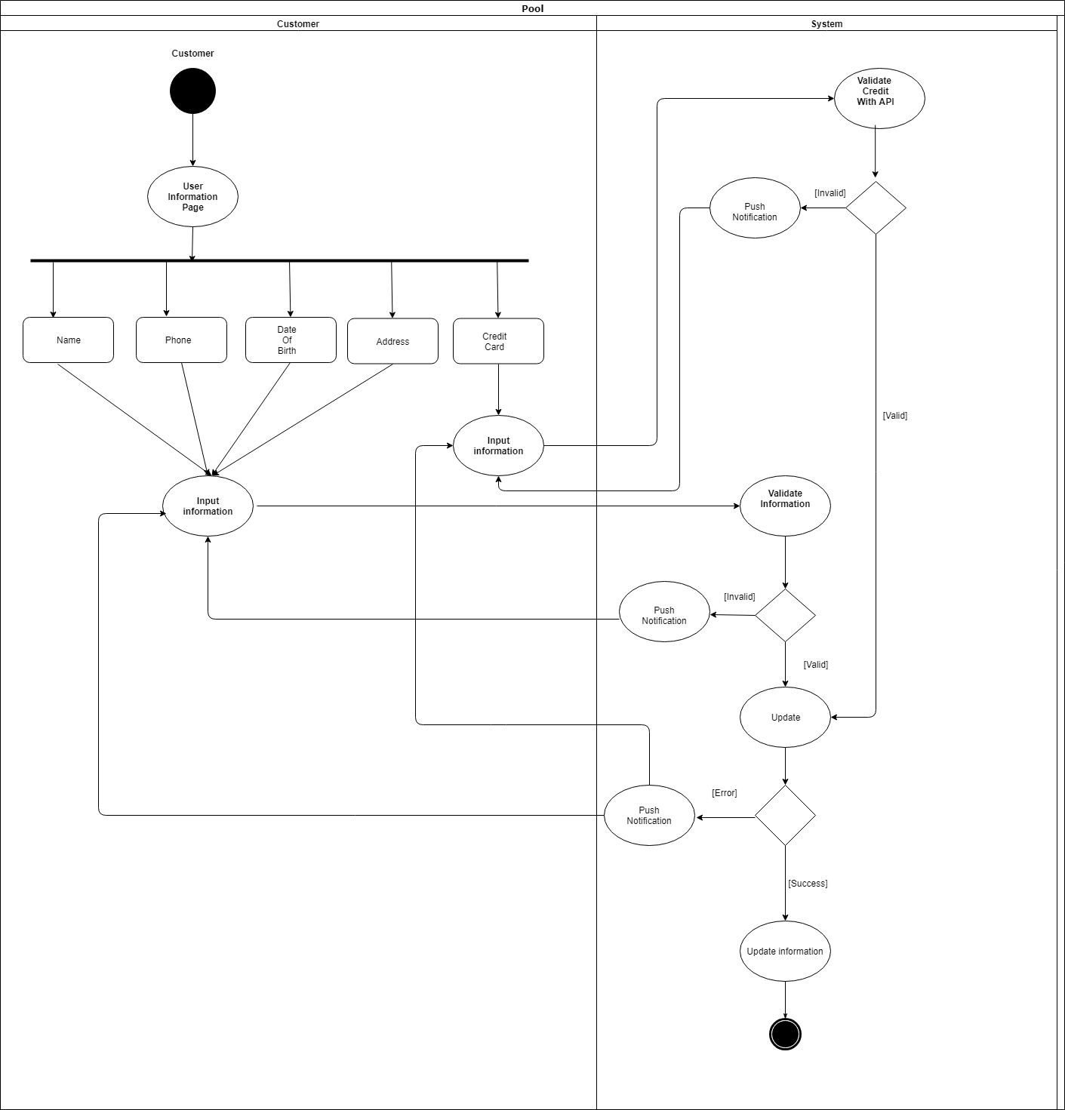

1. Activity diagram “ Login”

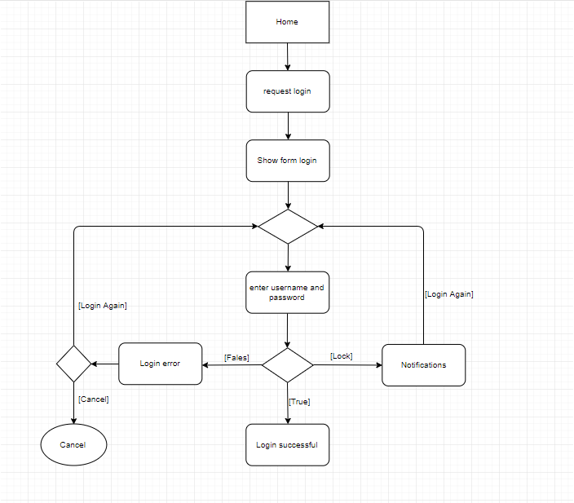

1. Activity diagram “ Upload images”

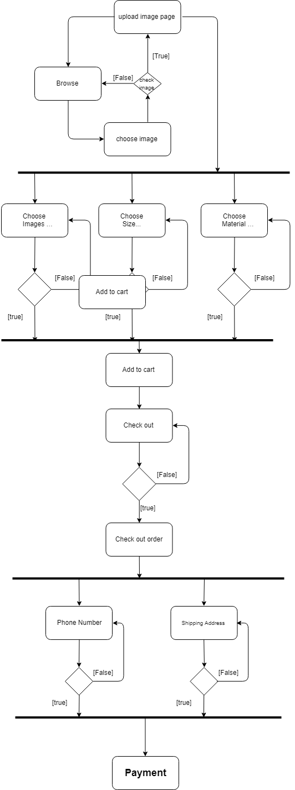

1. Activity diagram “Check out”

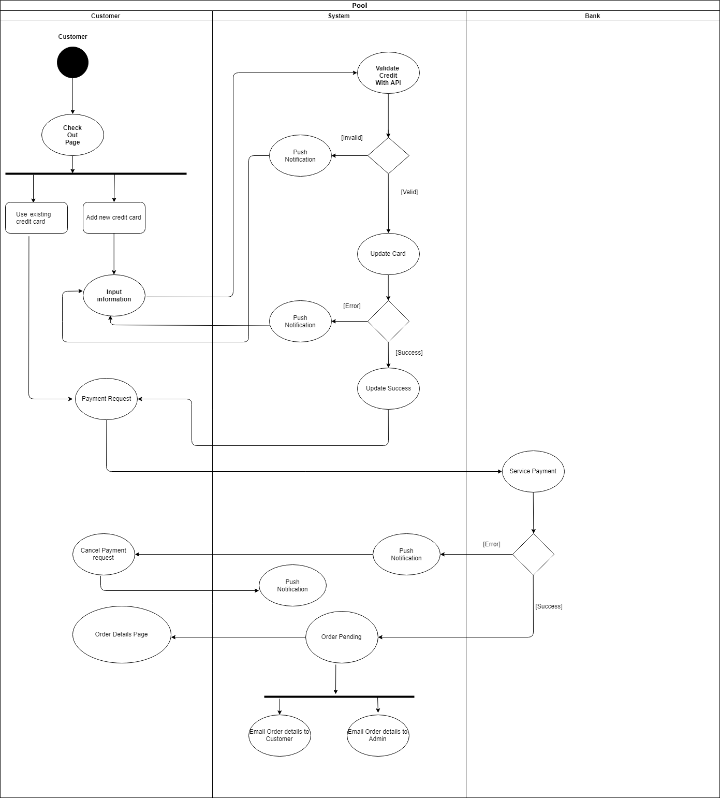

1. Activity diagram “Payment”



1. Activity diagram “ Login Admin”

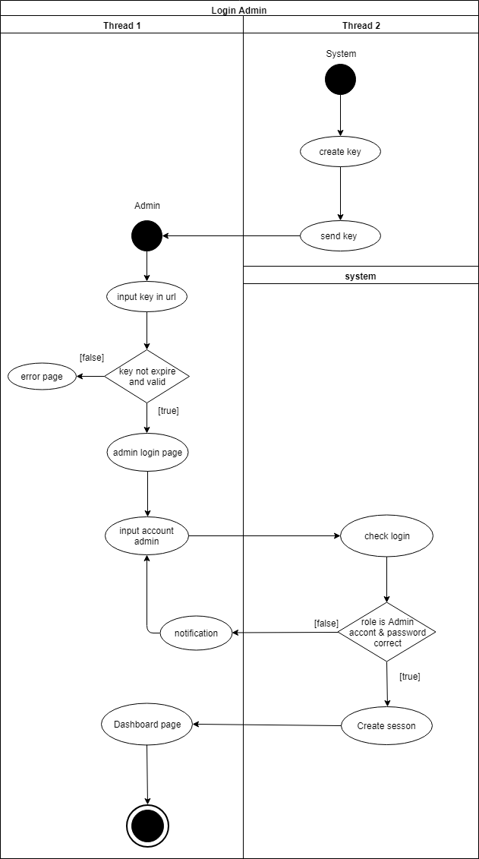

1. Activity diagram “Order Management”

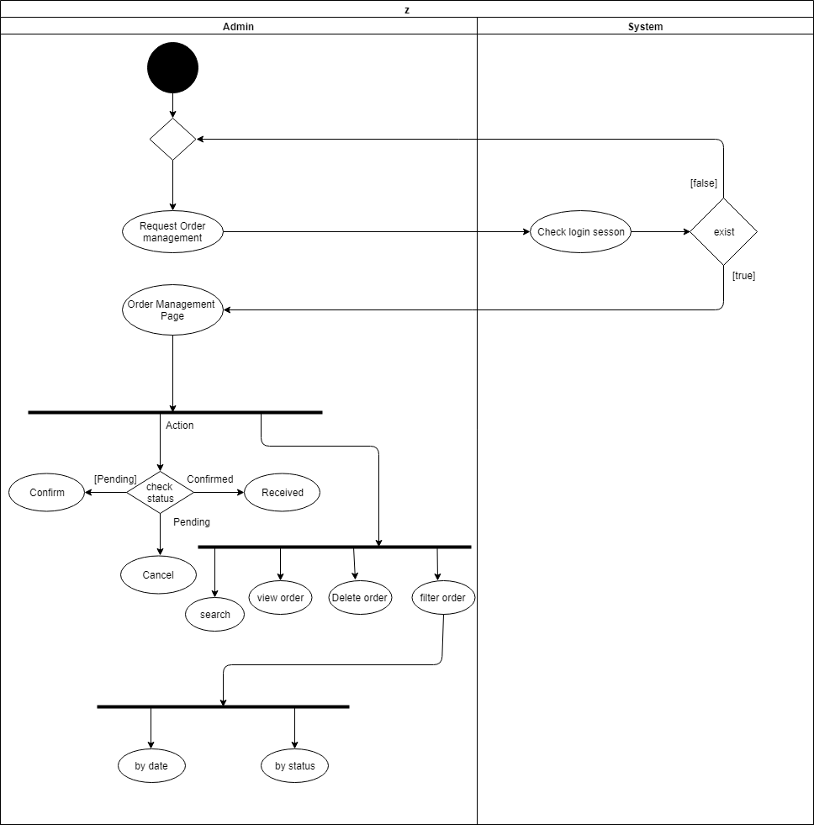

1. Activity diagram”size”

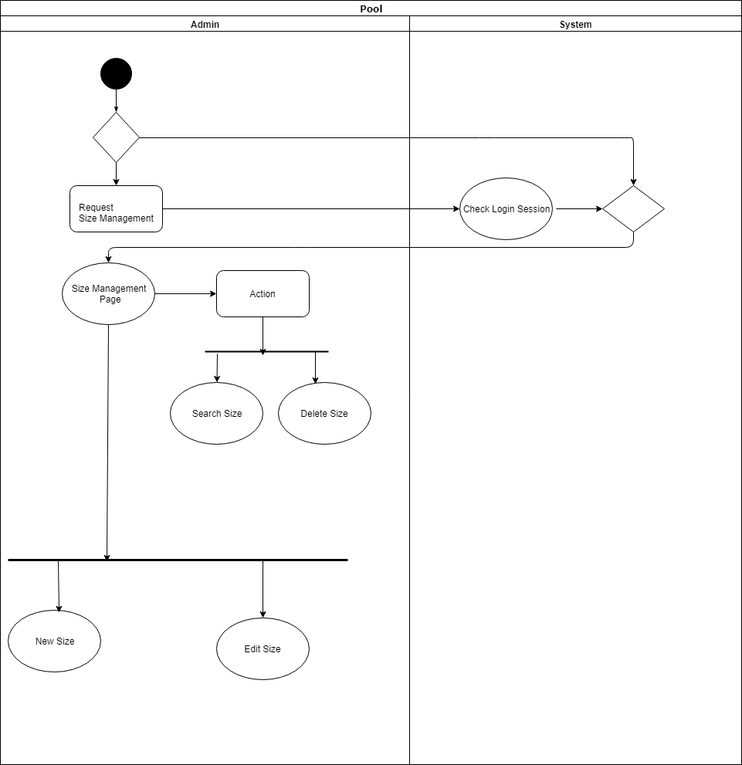

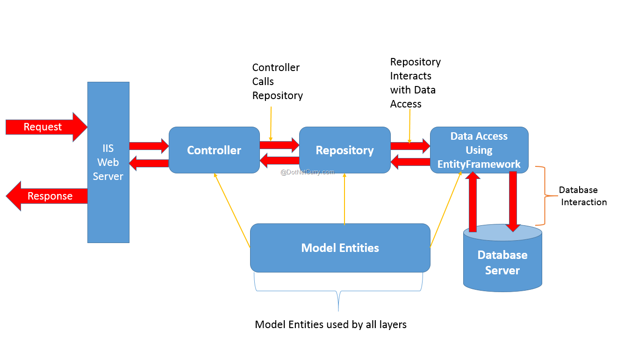

Activity diagram”materials”

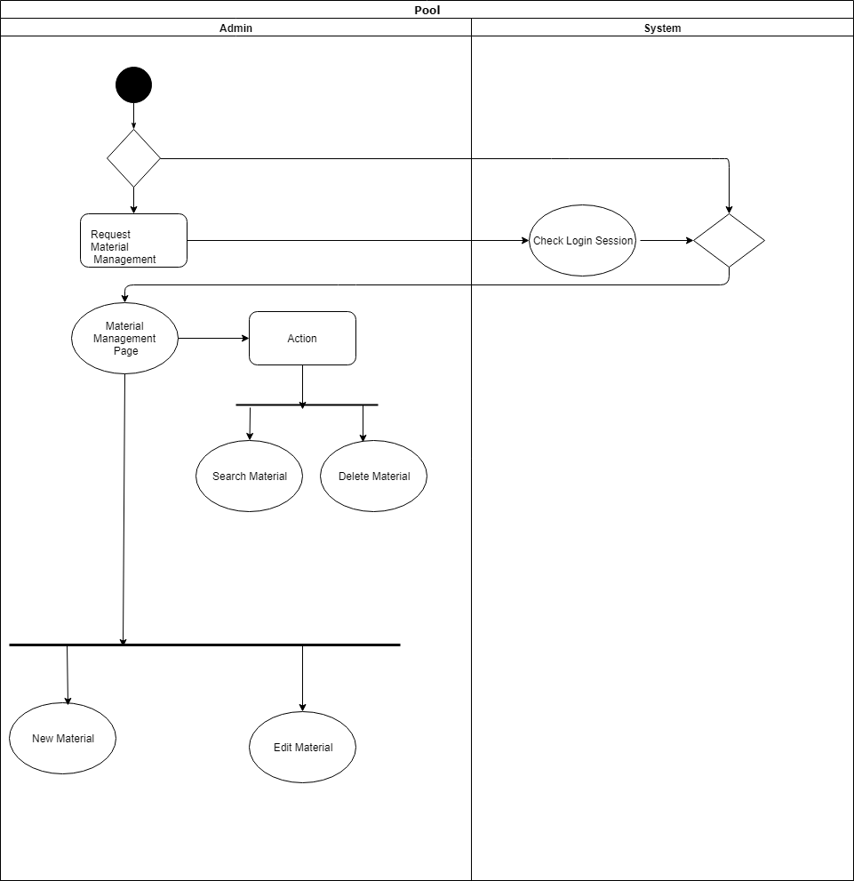

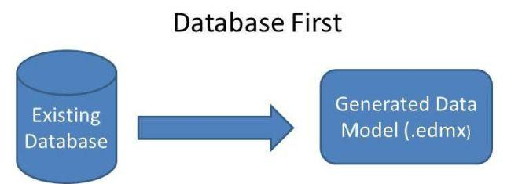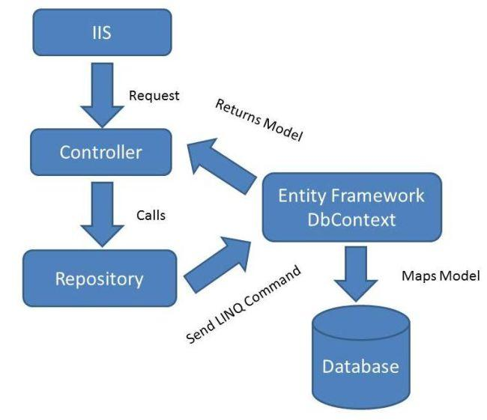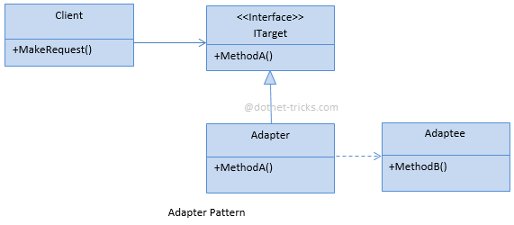

## 2.3 Use Case Diagram

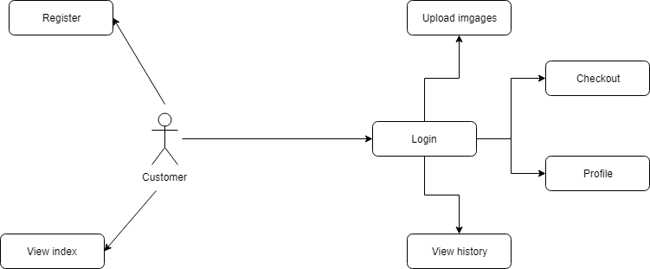

***Customer use case***

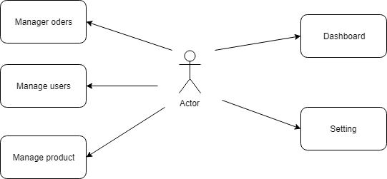

***Admin use case***

## 2.4 Use Case Specification (optional)

|  |  |
| --- | --- |
| **Actors** | Customer |
| **Brief Description** | - Use case allows the customer register to system |
| **Preconditions** | - The person has not already been registered with System |
| **Basic Flow of Events** | 1. The use case begins when customer click on ‘register’ button in website.  2.The system show register form contains      Fields:   * Full name. * Username. * Email. * Gender. * Password.   3. Customer enter information into form.  4.The system checks the validity of the information.  5. Save information of customer to database  6.System display successful register message. |
| **Alternative Flows** | A1. Exist use name:  If in step 4 of the basic flow customer enter a usename  existed in the database then:   1. System display error message. 2. The use case resumes at step 3 of Basic Flow enter other username.   A2. Email not valid:  If in step 4 of the basic flow customer enter a usename  existed in the database then:   1. System display error message. 2. The use case resumes at step 3 of Basic Flow re-enter email address.   A3. (Full name, password, Email, Gender) is null:  If in step 4 of the basic flow customer not  enter (Full name, password, Email, Gender) then:   1. System display error message. 2. The use case resumes at step 3 of Basic Flow enter requiment information. |
| **Exit Options** | - Customer  click on “Cancel”  button |
| **Special Requirements** |  |
| **Post Condition** | - Customer have a new account in system. |

|  |  |
| --- | --- |
| **Use Case Name** | **Login** |
| **Actors** | Customer, admin. |
| **Brief Description** | -Actors use this case to login to system |
| **Preconditions** |  |
| **Basic Flow of Events** | 1. Actors click on “Login “ button in website.  2.The system show” login” form contains      Fields :   * User name. * Password.   3. Actors enter username and password into form.  4.The system checks the validity of username and password .  5.System  logs the Actors into the system. |
| **Alternative Flows** | If in the step 4  Basic Flow,Customer enter invaild user name and/or password then:  1.System display error message.  2.The use case resumes at step 3 of Basic Flow. |
| **Exit Options** | - Actors click on “Cancel”  button |
| **Special Requirements** |  |
| **Post Condition** | - Actors login to system |

|  |  |
| --- | --- |
| **Use Case Name** | Upload Images |
| **Actors** | Customer. |
| **Brief Description** | -User use this case to upload images to system |
| **Preconditions** |  |
| **Basic Flow of Events** | 1. User click on “Start uploading “ button in website.  2.The system show” upload ” page contains      Fields :   * Select the image user want to upload. * Select size, material, options, quantity .   3. User import fields.  4.The system checks the validity.  5.System  logs the request into the system. |
| **Alternative Flows** | If in the step 4  Basic Flow,Customer enter then:  1.System display error message.  2.The use case resumes at step 3 of Basic Flow. |
| **Exit Options** | - User click “back”  button |
| **Special Requirements** |  |
| **Post Condition** | - User up load images to system |

|  |  |
| --- | --- |
| **Use Case Name** | Checkout |
| **Actors** | Customer. |
| **Brief Description** | - Users use this case to check out order |
| **Preconditions** |  |
| **Basic Flow of Events** | 1. User click on “Check out “ button in upload page.  2.The system show ” your cart ” page contains  3. User check information cart.  4.The system checks the validity.  5.System  logs the request into the system. |
| **Alternative Flows** | If in the step 4  Basic Flow,Customer enter then:  1.System display error message.  2.The use case resumes at step 3 of Basic Flow. |
| **Exit Options** | - User click “Contimue Upload”  button |
| **Special Requirements** |  |
| **Post Condition** | - User check information cart |

|  |  |
| --- | --- |
| **Use Case Name** | Payment Checkout |
| **Actors** | Customer. |
| **Brief Description** | - Users use this case to payment cart |
| **Preconditions** |  |
| **Basic Flow of Events** | 1. User click on “Confirm Checkout “ button in checkout  page.  2.The system show ” payment ” page contains  3. User choose payment type.  4.The system checks the validity.  5.System  logs the request into the system. |
| **Alternative Flows** | If in the step 4  Basic Flow,Customer enter then:  1.System display error message.  2.The use case resumes at step 3 of Basic Flow. |
| **Exit Options** | - User click “X”  button |
| **Special Requirements** |  |
| **Post Condition** | - User Payment Checkout |

# Design

## System Architecture

Website bases on MVC (Model-View-Controller) architecture

1. 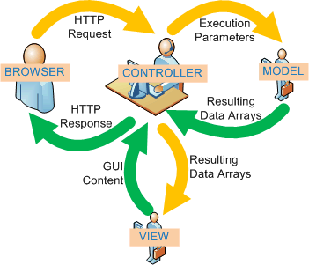

Web-Based Distributed MVC Architecture of the Project

## Class Diagram

## *Class diagram for entity class

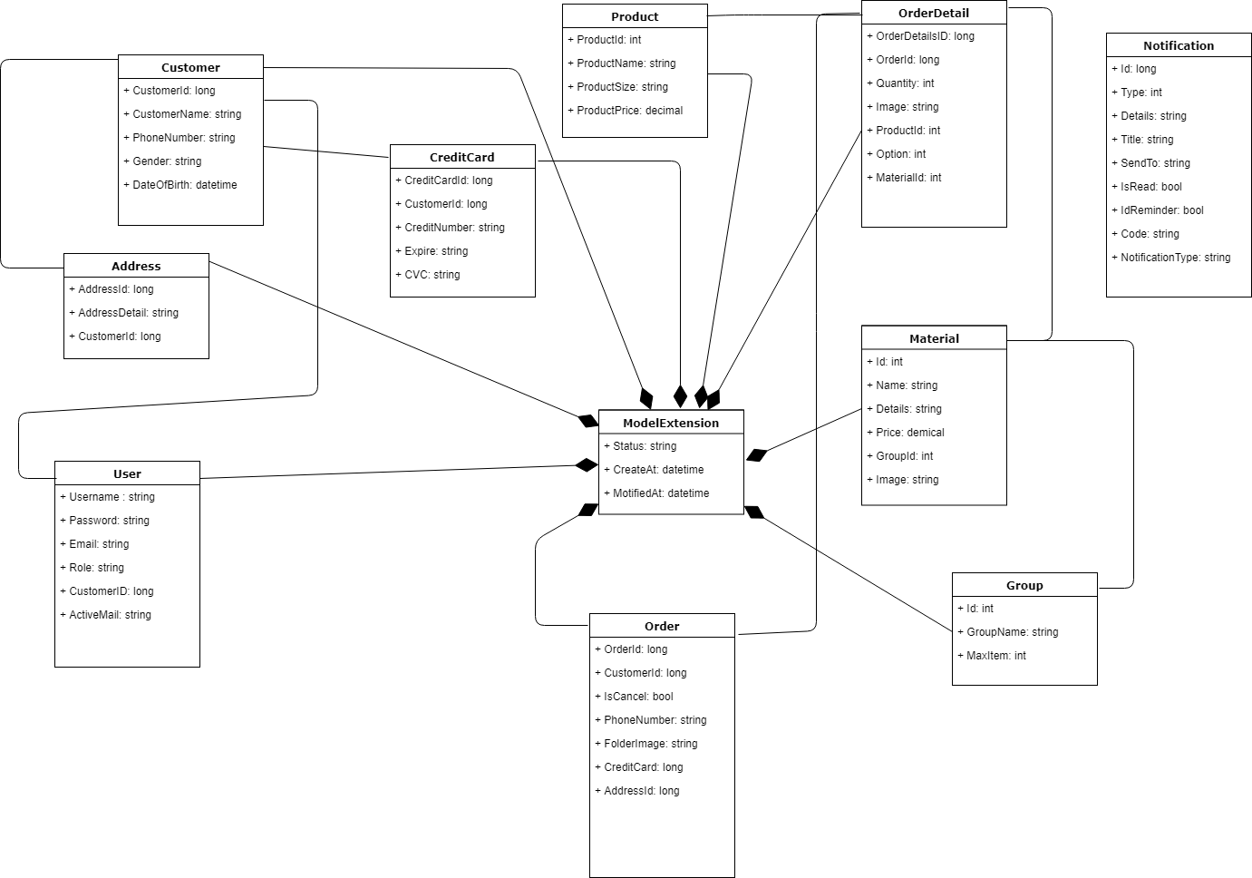

## Database design

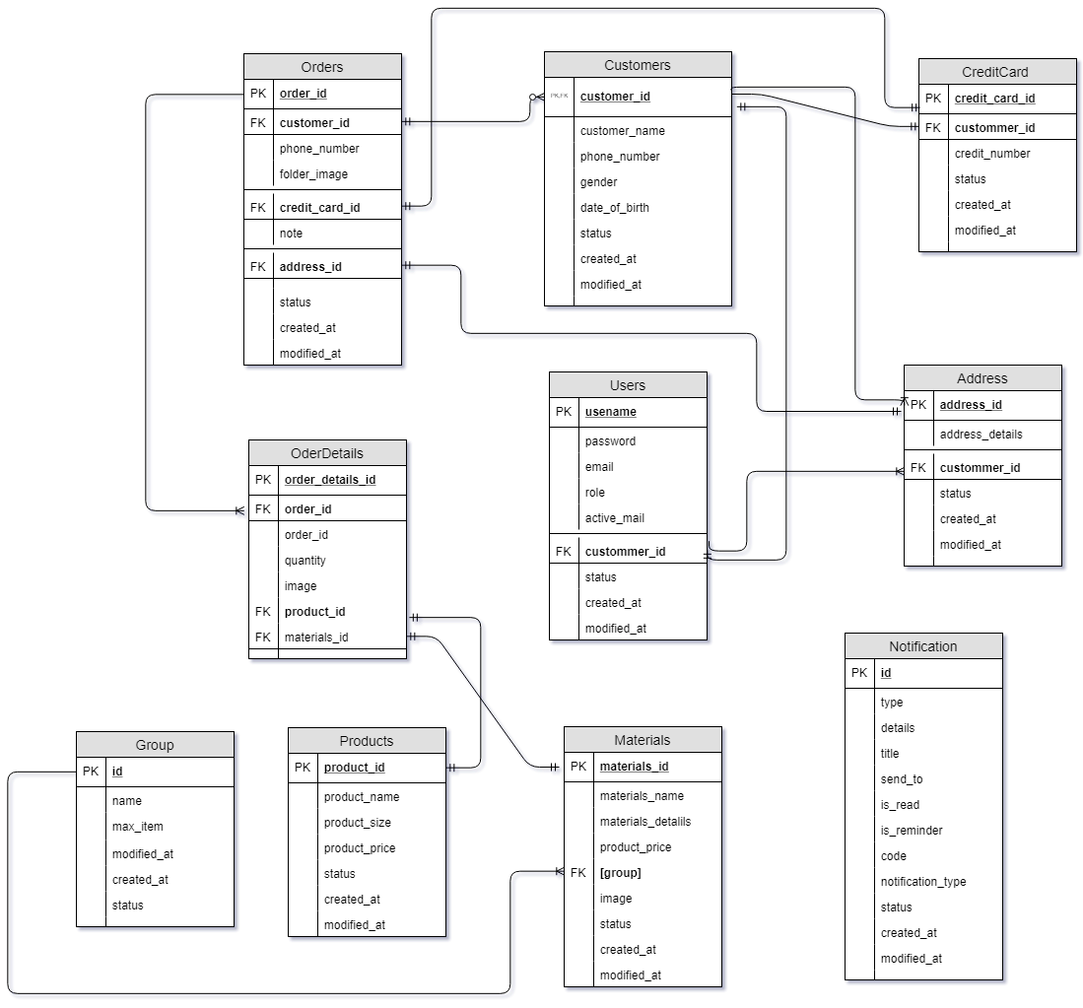

Table Users

|  |  |  |  |  |
| --- | --- | --- | --- | --- |
| **Field Name** | **Data Type** | **Null** | **Key** | **Description** |
| username | varchar(50) | notnull | PK | User name |
| password | varchar(50) | notnull |  | Password |
| email | nvarchar(max) | null |  | Email |
| role | varchar(10) | null |  | Role |
| active_email | varchar(100) | null |  | Active email |
| customer_id | bigint | null | FK | id Customer |
| status | varchar(10) | null |  | Status |
| created_at | datetime | null |  | Created at |
| modified_at | datetime | null |  | Modefied at |

Table Products

|  |  |  |  |  |
| --- | --- | --- | --- | --- |
| **Field Name** | **Data Type** | **Null** | **Key** | **Description** |
| product_id | int | notnull | PK | ID Product |
| product_name | nvarchar(50) | notnull |  | Name Product |
| product_size | varchar(20) | notnull |  | Size Product |
| product_price | money | notnull |  | Price Product |
| status | varchar(10) | null |  | Status |
| created_at | datetime | null |  | Created at |
| modified_at | datetime | null |  | Modified at |

Table Orders

|  |  |  |  |  |
| --- | --- | --- | --- | --- |
| **Field Name** | **Data Type** | **Null** | **Key** | **Description** |
| order_id | bigint | notnull | PK | ID Order |
| customer_id | bigint | null | FK | ID Customer |
| phone_number | varchar(11) | null |  | Phone Number |
| folder_image | varchar(100) | null |  | Folder Image |
| credit_card_id | bigint | null | FK | ID Credit Card |
| note | ntext | null |  | Note |
| address_id | bigint | null | FK | ID Address |
| status | varchar(10) | null |  | Status |
| created_at | datetime | null |  | Created at |
| modified_at | datetime | null |  | Modified at |

Table Order Details

|  |  |  |  |  |
| --- | --- | --- | --- | --- |
| **Field Name** | **Data Type** | **Null** | **Key** | **Description** |
| order_details_id | bigint | notnull | PK | ID Order Details |
| order_id | bigint | null | FK | ID Order |
| order_id | bigint | bigint |  | ID Order |
| quantity | int | null |  | Quantity |
| image | nvarchar(50) | null |  | Image |
| product_id | int | null | FK | ID Product |

Table Notification

|  |  |  |  |  |
| --- | --- | --- | --- | --- |
| **Field Name** | **Data Type** | **Null** | **Key** | **Description** |
| id | bigint | notnull | PK | ID Customer |
| type | int | notnull |  | Type Notification |
| destails | Nvarchar(50) | null |  | Destails Notification |
| title | Nvarchar(50) | null |  | Title |
| Sent_to | Nvachar(50) | null |  | Sent Notification |
| Is_real | bit | notnull |  | Notification |
| Is_reminder | bit | notnull |  | Reminder Notification |
| code | Nvachar(100) | null |  | code |
| notification_type | Nvachar(100) | null |  | Box(drop down) |
| status | Nvachar(10) | null |  | Status |
| Created_at | datetime | null |  | Created Notification |
| modified_at | datetime | null |  | Modified at |

Table Credit Card

|  |  |  |  |  |
| --- | --- | --- | --- | --- |
| **Field Name** | **Data Type** | **Null** | **Key** | **Description** |
| credit_card_id | bigint | notnull | PK | ID Credit Card |
| customer_id | bigint | notnull | FK | ID Customer |
| credit_number | varchar(20) | null |  | Credit Number |
| Credit_expire | Nvachar(5) | null |  | Expire card |
| cvc | Nvachar(3) | null |  | Cvc card |
| status | varchar(10) | null |  | Status |
| created_at | datetime | null |  | Created at |
| modified_at | datetime | null |  | Modified at |

Table Address

|  |  |  |  |  |
| --- | --- | --- | --- | --- |
| **Field Name** | **Data Type** | **Null** | **Key** | **Description** |
| address_id | bigint | notnull | PK | ID Address |
| address_detail | nvarchar(255) | null |  | Detail Address |
| customer_id | bigint | null | FK | ID Customer |
| status | varchar(10) | null |  | Status |
| created_at | datetime | null |  | Created at |
| modified_at | datetime | null |  | Modified at |

Table Material

|  |  |  |  |  |
| --- | --- | --- | --- | --- |
| **Field Name** | **Data Type** | **Null** | **Key** | **Description** |
| material id | bigint | notnull | PK | ID Address |
| Material name | Nvachar(50) | null |  | Name Customer |
| material detail | Nvarchar(50) | null |  | Detail Address |
| material price | bigint | null |  | ID Customer |
| group | Int | null | FK | group |
| image | Nvachar(100) | null |  | Image Customer |
| status | Nvachar(10) | null |  | status |
| created_at | datetime | null |  | Created at |
| modified_at | datetime | null |  | Modified at |

Table Migrationhistory

|  |  |  |  |  |
| --- | --- | --- | --- | --- |
| **Field Name** | **Data Type** | **Null** | **Key** | **Description** |
| Migrationld | Nvachar(150) | notnull | PK | Migrationld |
| contextkey | Nvachar(300) | notnull | FK | contextkey |
| model | Varbinary(max) | notnull |  | Customer |
| Productversion | Nvachar | notnull |  | version |

1. ***System Prototype***



# *Checklists*

## Check List of Validation

|  |  |
| --- | --- |
| **Checklist Option** | **Validated** |
| Can a new user who gets registered, enter the web site after logging in? | Yes |
| Do all the links navigate to the correct web page? | Yes |
| Does the web site’s functionality resolve the client problem and satisfy his need? | Yes |
| Has the hardware and software been correctly chosen? | yes |

## Submission Checklist

|  |  |  |  |  |  |
| --- | --- | --- | --- | --- | --- |
| **Sr.No** | **Particulars** | **Yes** | **No** | **NA** | **Comments** |
| 1 | Are the users able to enter the web site after validation is performed on  the UserID and password? | Yes |  |  |  |
| 2 | Are the users able to enter the web site after getting registed? | Yes |  |  |  |
| 3 | Do all the web page contents are devoid of spelling mistakes? | Yes |  |  |  |
| 4 | Is the user able to post entry to the web site | Yes |  |  |  |
| 5 | Do all user and visitor able to view forum | Yes |  |  |  |
| 6 | Admin able manage activity of forum | Yes |  |  |  |
| 7 | Is the web site user- friendly | Yes |  |  |  |

1. ***Screenshots***

#### *7.1 Home*



#### *7.2 User Register*

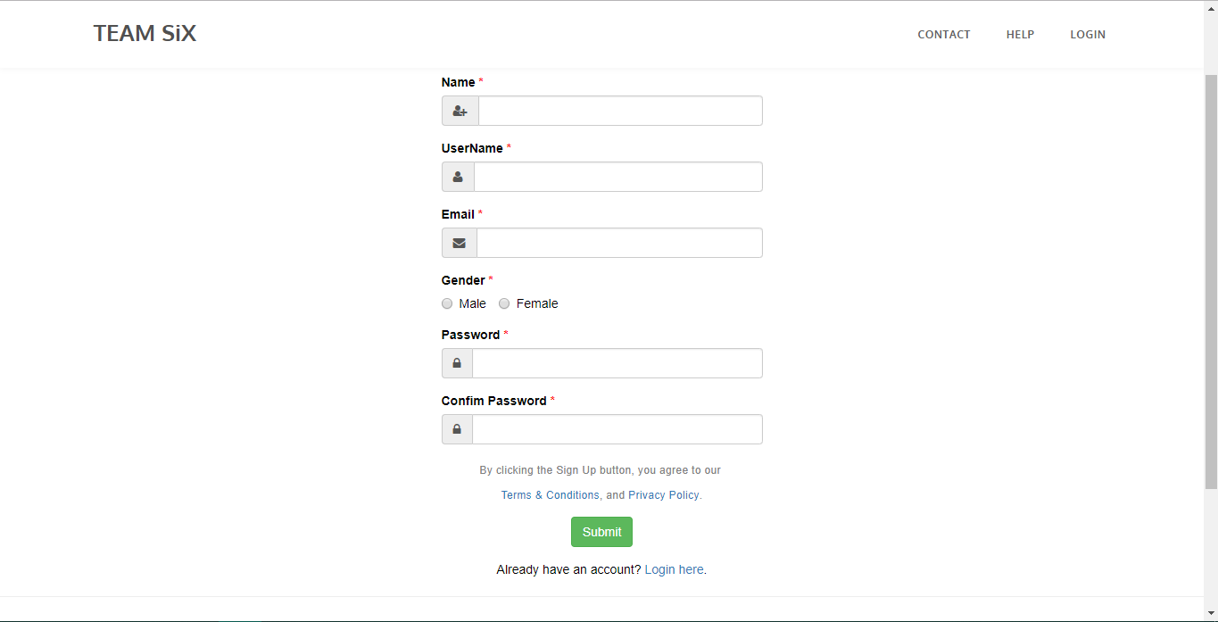

#### *7.3 UserLogin*

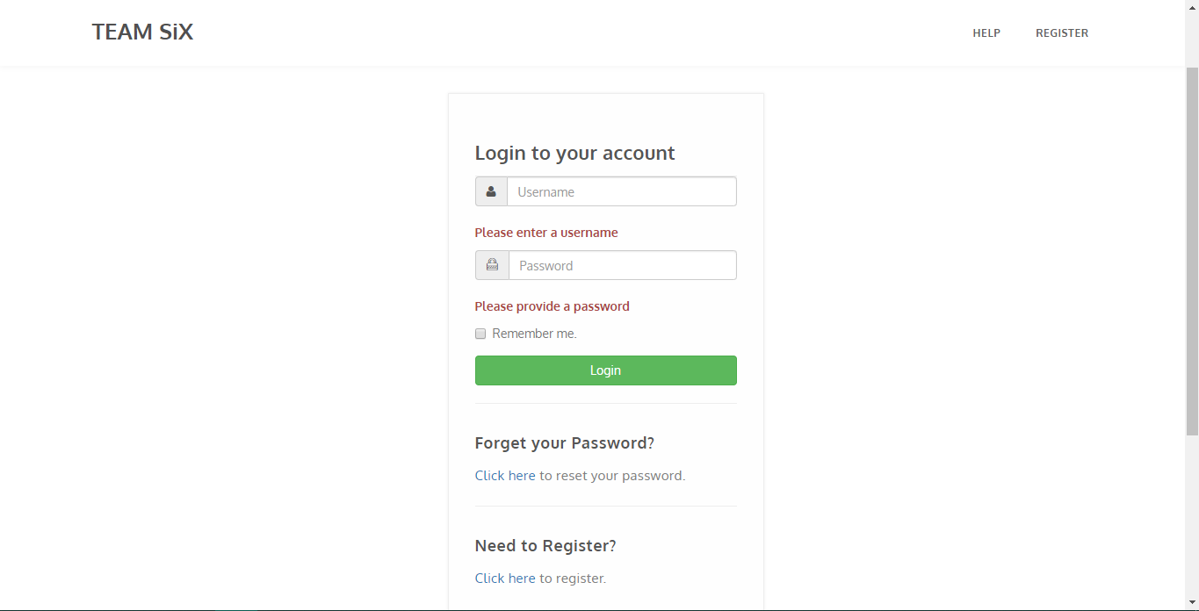



#### *7.4 User Infor*

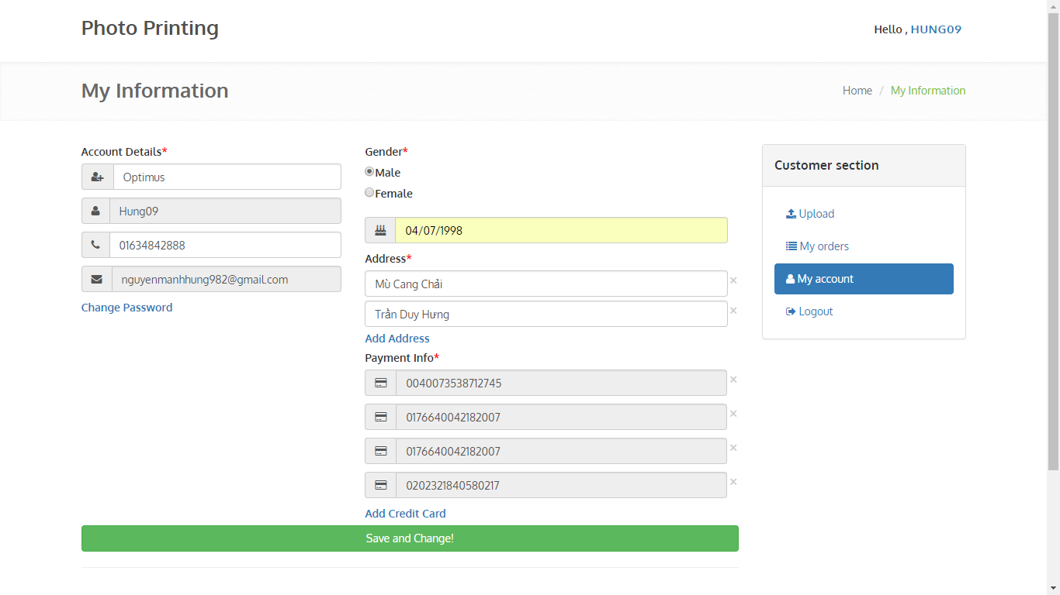

#### *7.5 Upload Image*

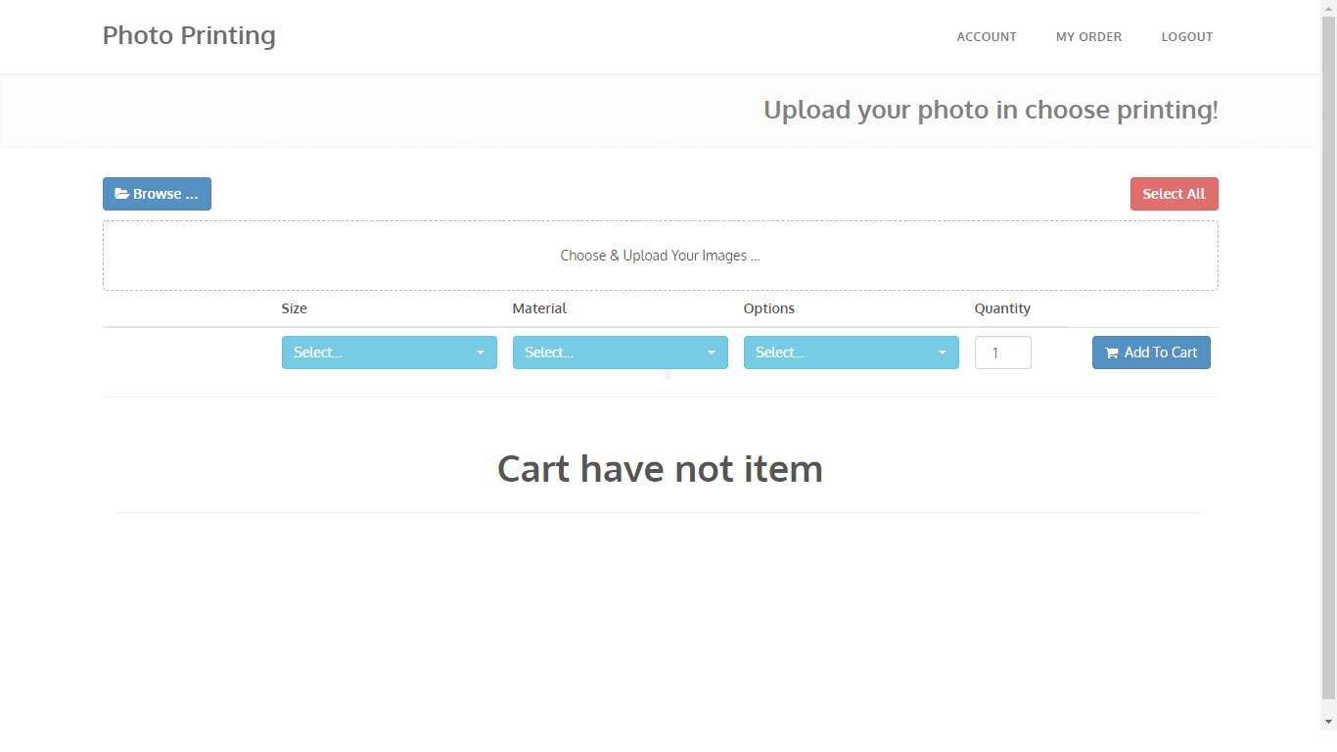

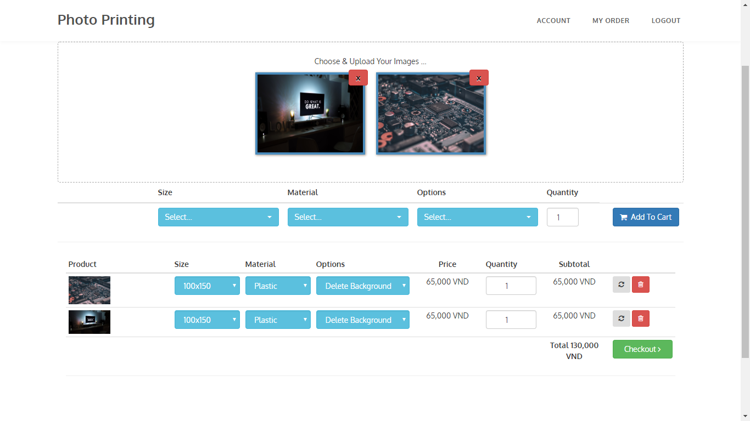

#### *7.6 Check Out*

#### *7.7 Payment Checkout*

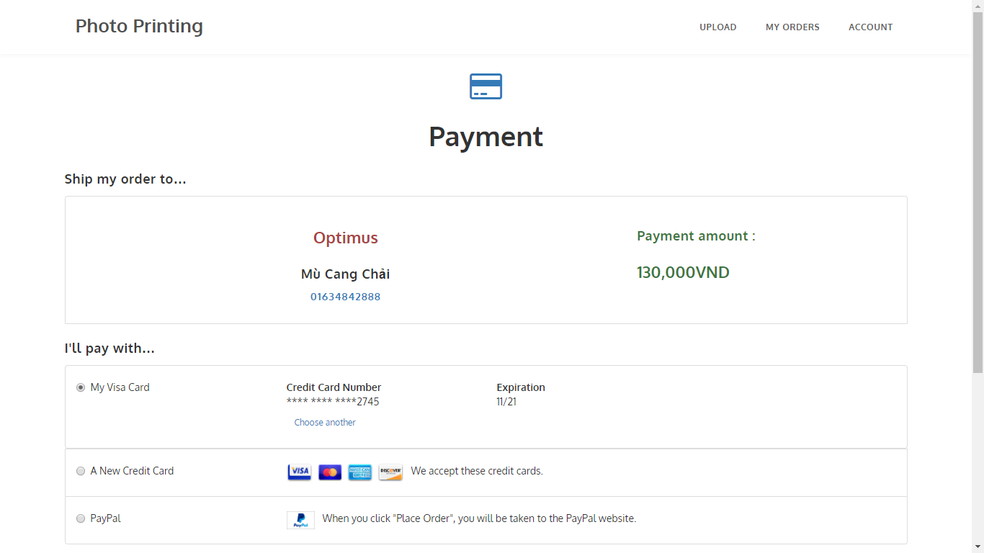

#### *7.8 Add NewCart*

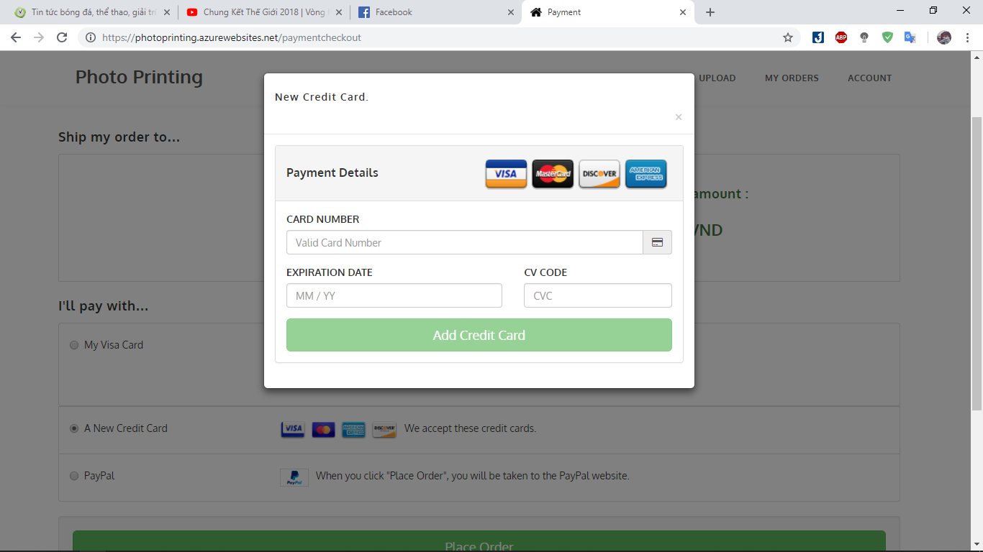

#### *7.9 Details*

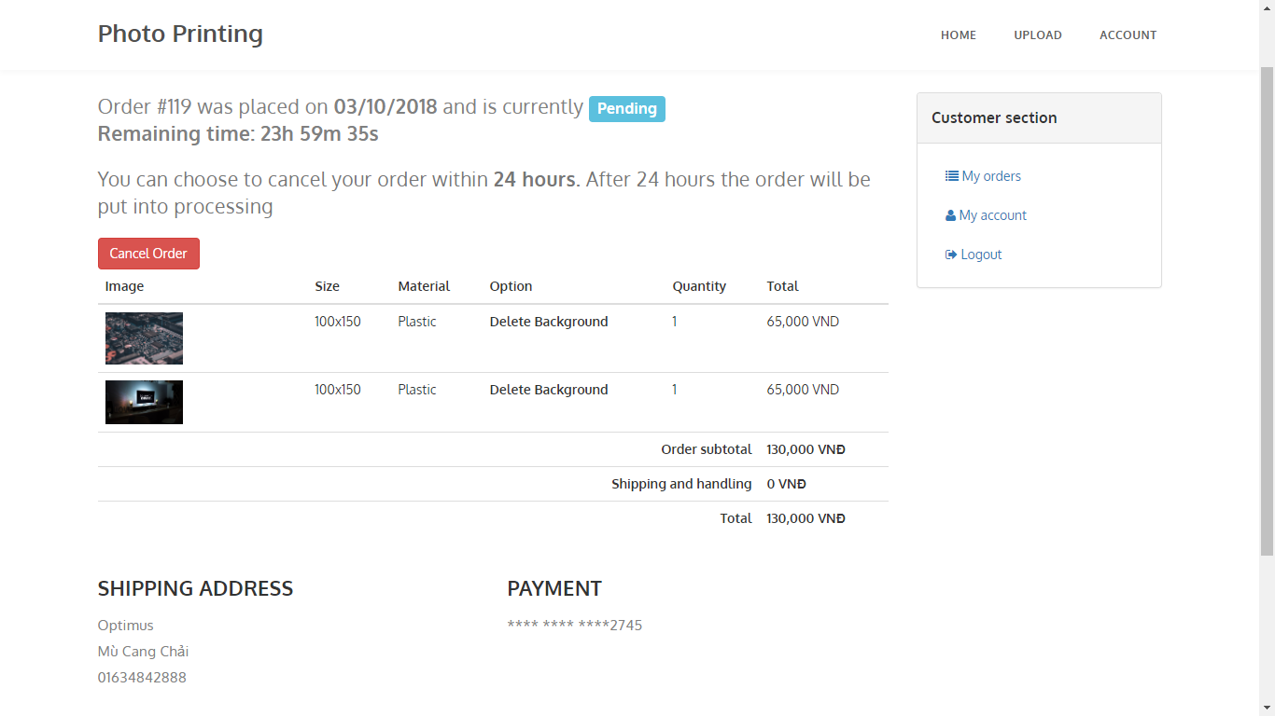

#### *7.10 My Orders*

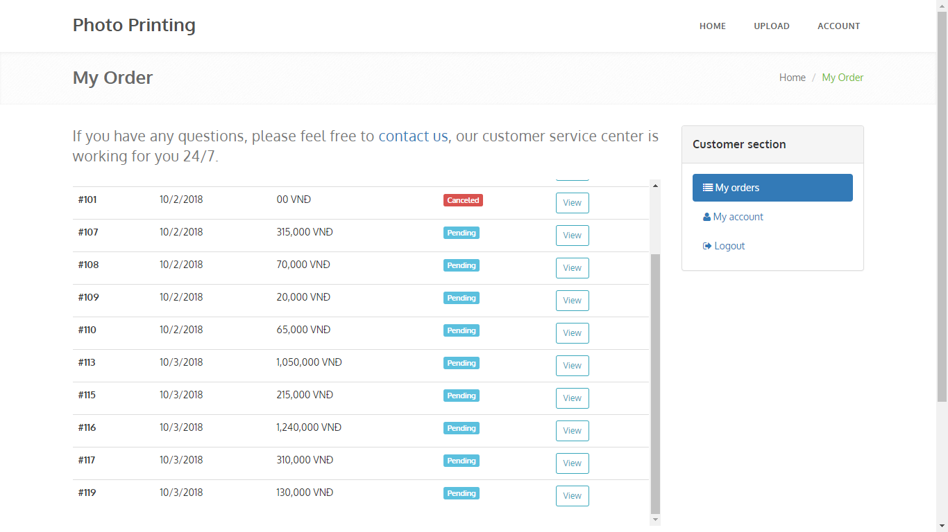

#### *7.11 Mail*

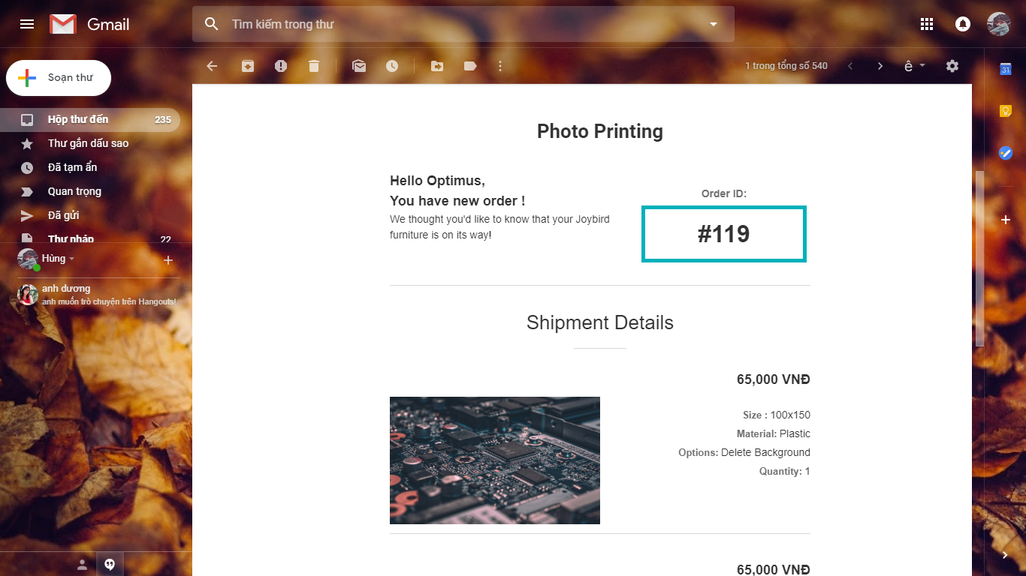

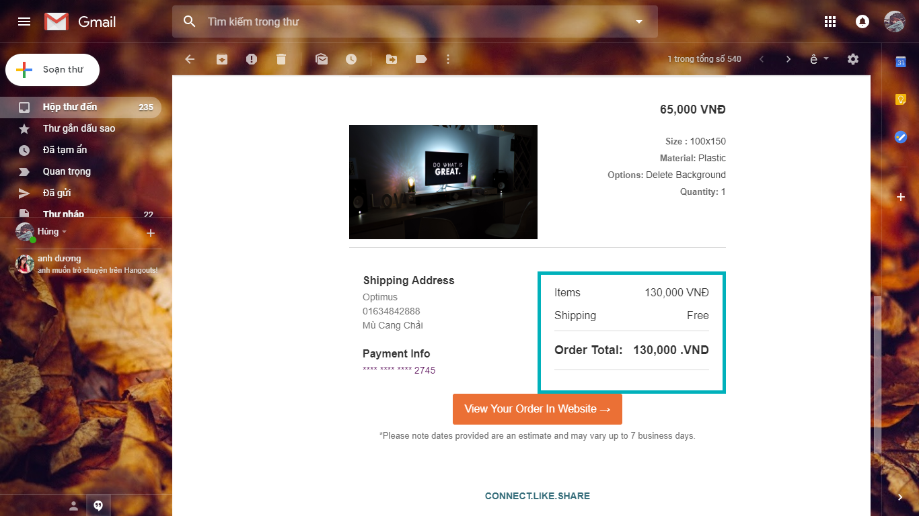

#### *7.12* Notifications



#### *7.13 User Login Admin*

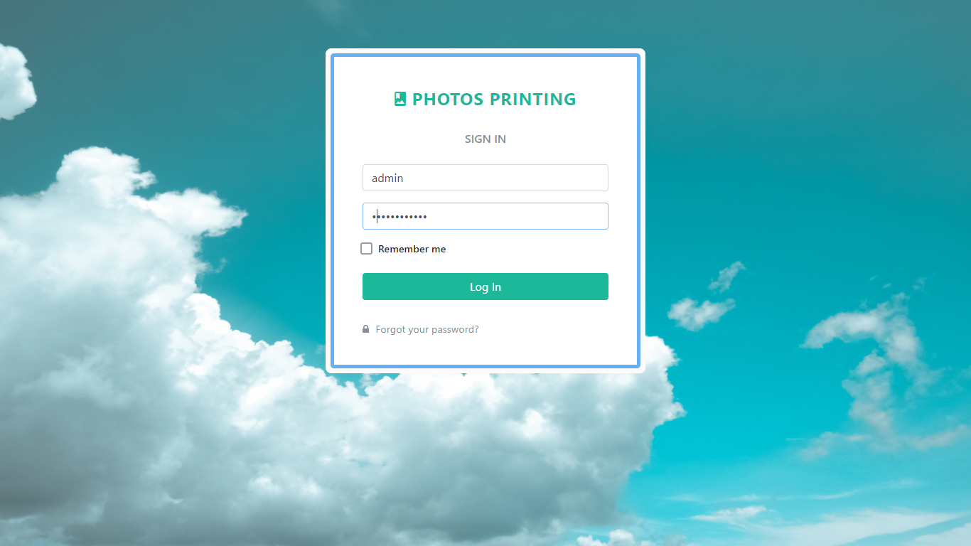

#### *7.14 Admin Manager*

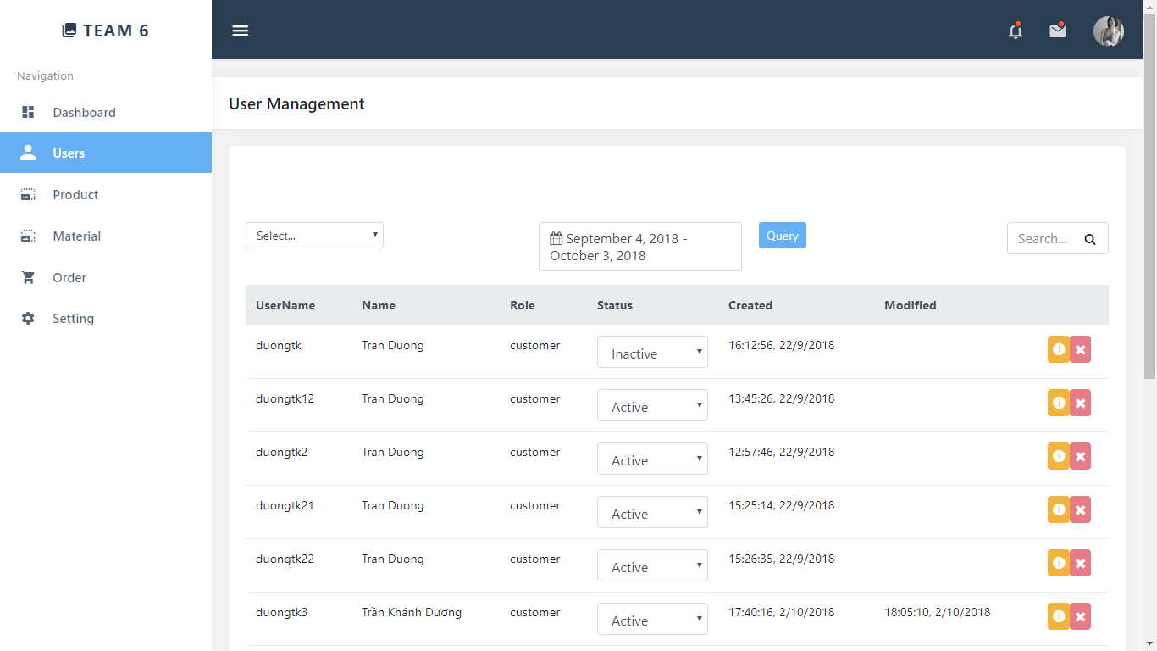

#### *7.15 Admin Management*

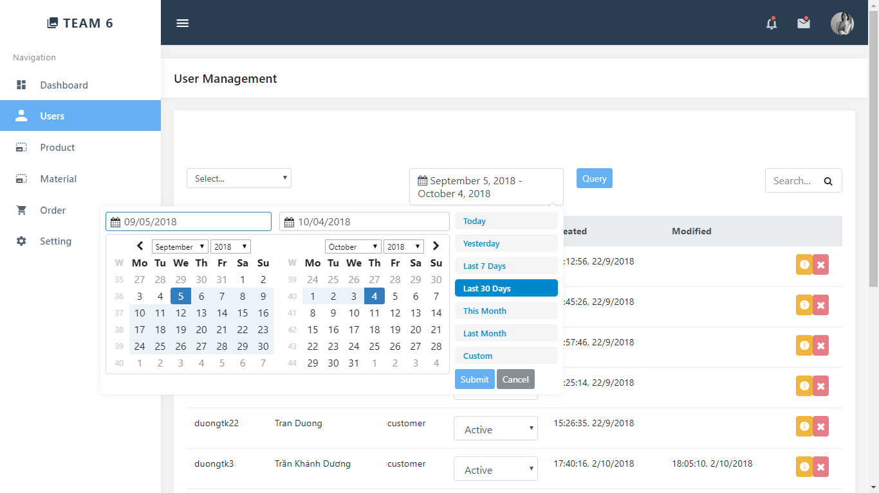

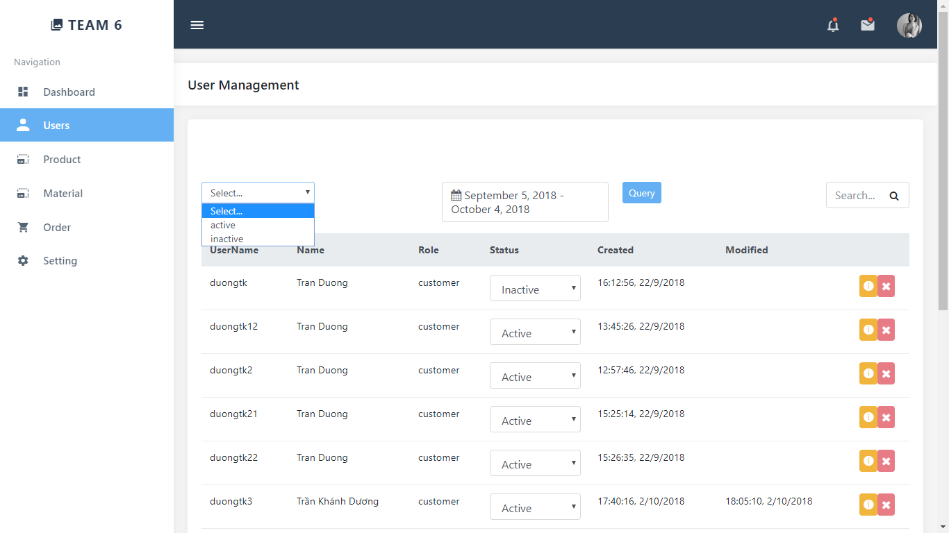

#### *7.16 Size*

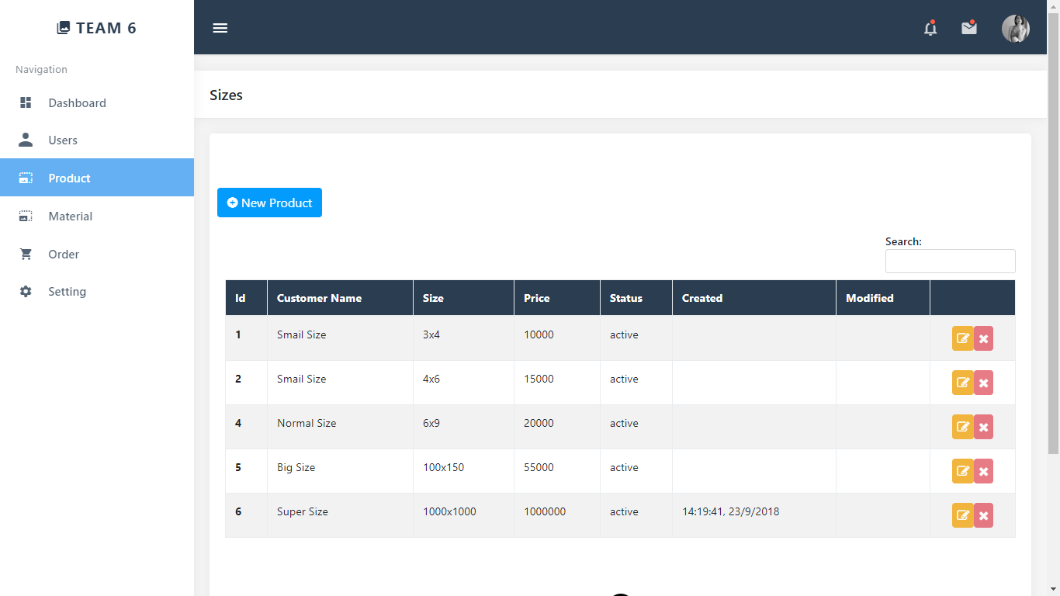

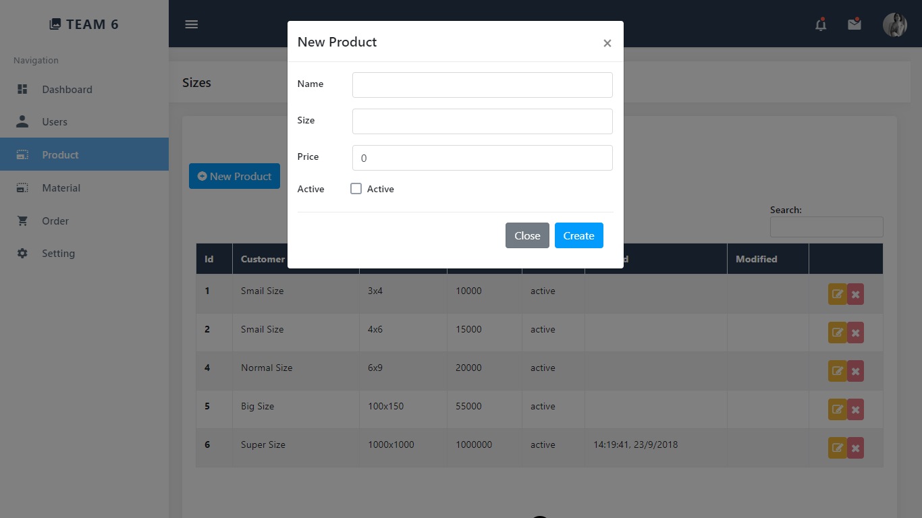

#### *7.17 Material*

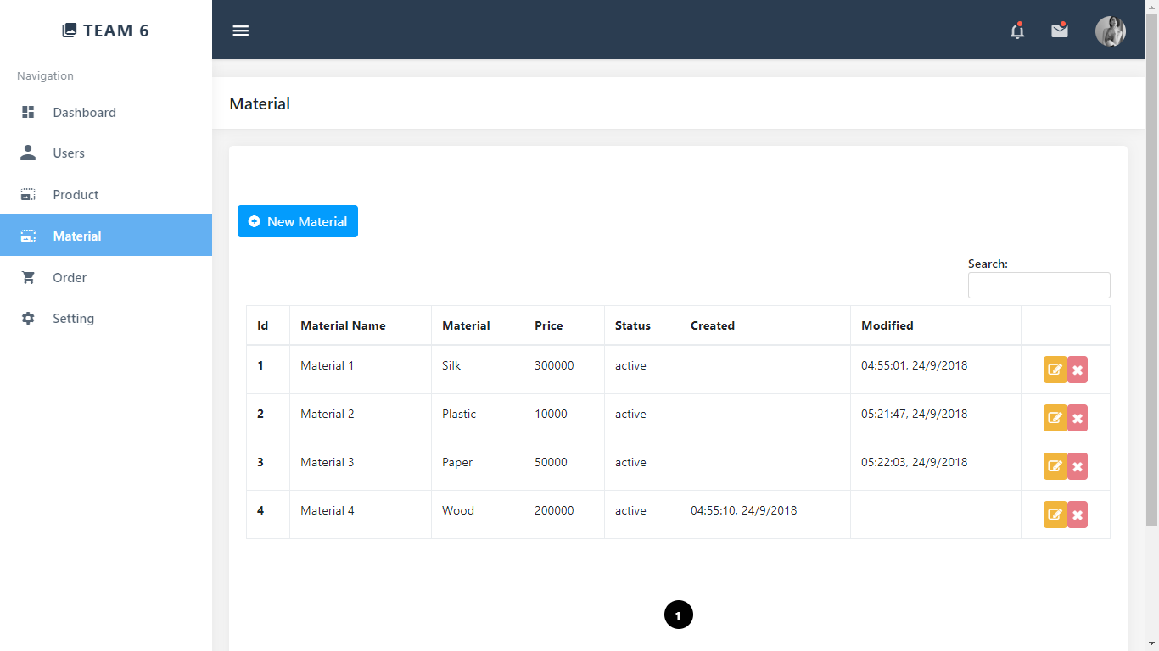

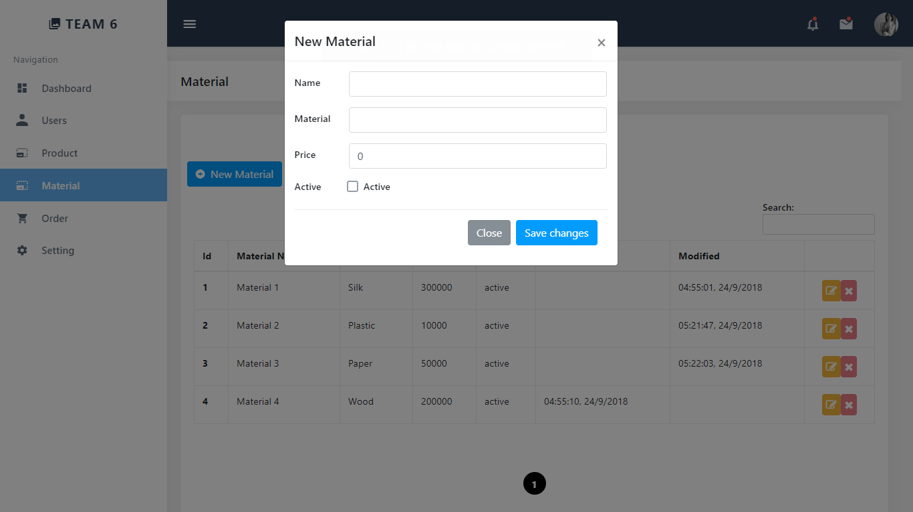

#### *7.18 Order*

